**III Unit**

**Memory Management**

**Multiprogramming with fixed partitions (MFT)**

In this the user memory is divided into definite areas called partitions, the number and size of each partition is fixed. If there are 4 partitions which are of sizes 2k, 7k, 9k, 12k then the no. of partitions and size of each partition cannot be changed during the life of the system. The size of each partition is determined by making a study on the length of incoming jobs. The incoming jobs are constantly monitored and allocation is done in a partition where it approximately fits in.

|  |  |
| --- | --- |
| O.S |  |
| 2K | P1 |
| 7K | P2 |
| 9K | P3 |
| 12k | P4 |

**Example**:

|  |  |  |  |  |  |
| --- | --- | --- | --- | --- | --- |
| 12K | 10K | 6K | 8K | 5K |  |

J5 J4 J3 J2 J1

Let us assume there are 5 jobs in job Queue as shown in the above fig. Job 1 can be fit in any one of the partitions P2, P3. P4. However, If Job 1 is fit in P3. P4 partitions then the internal fragmentation are more. Hence Job 1 is stored in partition P2 and there is an internal fragmentation of 2k, Job2 is stored in partition P3 and producing an internal fragmentation of 1k. Job3 is stored in partition P4, producing an internal fragmentation of 6k. There are two ways of storing Job3 in memory.

1. Store Job3 in partition P4 producing large amount of internal fragmentation.
2. Make Job3 wait until partition P2 is freed.

Once the Job completed execution, then the respective partition is freed. If we assume that Job3 is stored in partition P4 then the remaining two Jobs Job4 and Job5 cannot be stored in any partition because all the partitions P2. P3, P4 are occupied with some Jobs.

Here Job4 and Job5 are made wait until the partitions P4 is freed. When partition P4 is free, then Job4 goes to partition P4 after completion of it, Jobs goes to P4. Here partition P1 is not allocated to any Jobs. Since there is no Job of size less than or equal to 2K in the Job queue. Therefore entire partition P1 is empty and this is called external fragmentation.

MFT suffers from both internal fragmentation and external fragmentation. Fragmentation is defined as waste of memory space. Internal fragmentation is defined as waste of memory space in a partition.

**Example** - Let there be a partition of size 10K and the program of size 9K is allocated to that partition. Then internal fragmentation of 1K (IOK-9K) this 1K cannot be allocated to any program. Since one partition should contain only one program.

External fragmentation is defined as wastage of memory space in the entire partition.

**Example** :- Suppose there is partition of size 2K but there are no Job in the Job queue of size less than or equal to 2K then the entire 2K partition left empty. This called external fragmentation.

There is major disadvantage in MFT is that if there is a program of size 15K which cannot be allocated in any partition then the system fails to allocate memory for that program. To overcome this disadvantage we use MVT.

**Multiprogramming with Variable Partition (MVT):**

In MFT too much of memory is wasted when program sizes are smaller than partition sizes i.e. There is an internal fragmentation in MFT. Also if there is a program of size 25K, but there are no partitions of size greater than or equal to 25K then memory cannot be allocated for this 25K program. To overcome this disadvantage MVT is used.

In MVT partitions are not static i.e. partitions are created dynamically. The memory has a whole is considered as a single partition i.e. initially, in MVT, the entire memory is considered as a single partition is called **HOLE**. Let us assume the memory size is 256K. O.S. Occupies 40K (Say). Then the remaining 216K is left for user programs. This entire 216K is treated as a single partition.

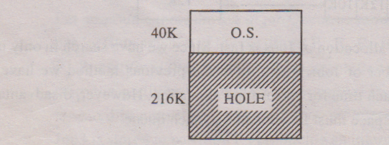

Let us assume there are 5 Jobs with sizes shown below:

|  |  |
| --- | --- |
| **Job** | **Sizes** |
| J1  J2  J3  J4  J5 | 60K  100K  70K  30K  80K |

Now the 216K hole is divided into two partitions. Where one partition contains J1 and second partition is a hole of size 156K. Thus memory is divided into partitions based on the sizes of the Jobs. This is called dynamic partitioning. The memory allocation for Jobs is done as follows.

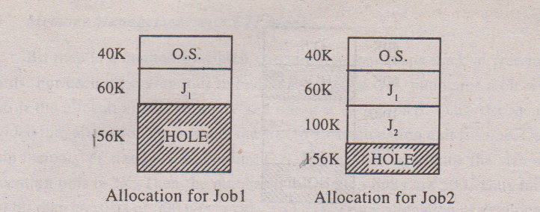

Allocation for Job3 cannot be done since program of size 70K is greater than hole size.

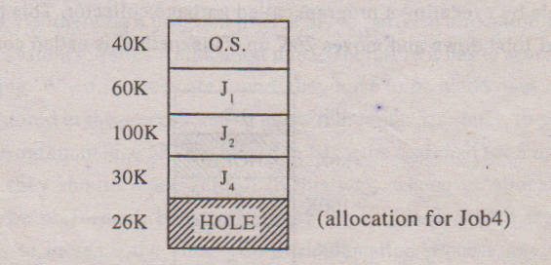

The Jobs J3 and J5 cannot be accommodated in memory since there is no Hole of enough size. This means J3 and J5 have to wait until any one of the Jobs present in main memory completes execution. Thus MVT memory management is as follows.

When a Job arise and needs memory, operating system searches for a Hole which is large enough to accommodate the Job, if it finds one, memory is allocated by dividing the hole into two partitions where one partition is accommodated for Job and second partition is left empty to satisfy the future request. MVT also suffers from external fragmentation. In the above fig. the 26K cannot be accommodated for any Job present in the Job queue. Therefore, this 26K is external fragmentation.

Suppose J1 completes execution, then it leaves memory and the 60K becomes a hole. Thus we have two non-adjacent Holes of sizes 60K and 26K. Neither J3 nor J5 can be accommodated in these Holes (without combining). Suppose if these holes are adjacent to one another then we get a single large hole of size 86K and allocation can be done for Job3. But presently these two holes are non adjacent.

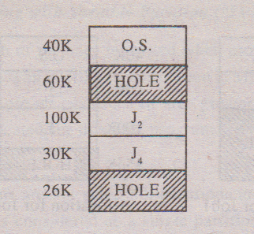

Hence operating system combines these two non adjacent Holes into a single large hole by executing a program called garbage collector. This program relocates Job2 and Job4 down and moves 26K up. This method is called compaction.

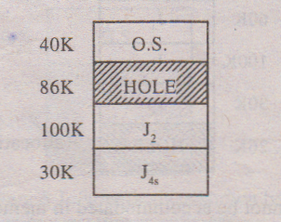

Now allocation for Job3 is done in 86K hole. Compaction is a time consuming process i.e. Executing garbage collector requires considerable time. Hence compaction should be employed only if it is necessary.

**MEMORY MANAGEMENT**

**Introduction to Memory**

Memory is an essential part of computer system as both CPU and I/O devices accessing. Due to this reason; we should try to efficiently manage the memory for maximum utilization of computer system. The part of the operating system that manages the memory is called memory manager. Its job is to keep track of which part of memory are in use and which parts are not in use, allocate memory to the programs when they need it, deallocate memory when the programs completes the execution and to manage swapping between main memory and disk when the main memory is not big enough to hold all the processes. Memory Management system can be divided into two classes.

1. Those that move process between main memory and disk during execution.

2. Those that do not move process between main memory and disk. This is called monoprogramming without swapping.

**Logical Address and Physical Address**

Logical address is a address which is written by user. During execution CPU generates logical address (logical address is also called as virtual address). Now O.S. should convert this logical address into physical address. User developed a program having contiguous memory locations in this mind. But the program is stored in memory contagiously. The view of the memory the user has termed as logical memory. The actual memory in the system called physical memory. For the program run successfully mapping should take place i.e. logical address must be converted to physical address. When CPU generates logical address, it is converted into physical address and CPU will access this physical memory location. Thus physical address is a address where actual information is present.

**Swapping**

Swapping is a mechanism in which a process can be swapped temporarily out of main memory to a backing store, and then brought back into memory for continued execution.

Backing store is a usually a hard disk drive or any other secondary storage which fast in access and large enough to accommodate copies of all memory images for all users. It must be capable of providing direct access to these memory images.

Major time consuming part of swapping is transfer time. Total transfer time is directly proportional to the amount of memory swapped. Let us assume that the user process is of size 100KB and the backing store is a standard hard disk with transfer rate of 1 MB per second. The actual transfer of the 100K process to or from memory will take

100KB / 1000KB per second

= 1/10 second

= 100 milliseconds

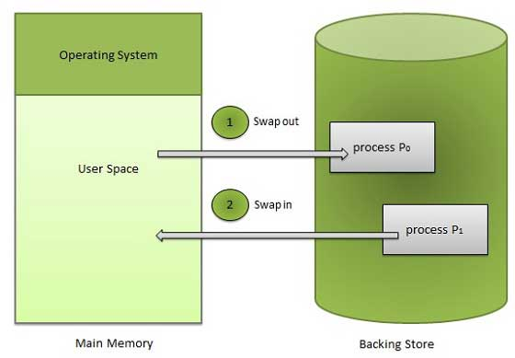

**Internal Fragmentation and External Fragmentation**

If the partition size is fixed then there may be internal fragmentation.

**Example:** Consider a partition of size 1000 words. There is a program of size 800 words then this program is stored in the partition and the remaining 200 words are internal fragmentation i.e. the remaining 200 words are wasted i.e. we cannot store another program in this 200 words (because partition can accommodate the program only) MFT, paging suffers from internal fragmentation. If the partition size is not fixed there will not be internal fragmentation.

Whether the partition is fixed or not, there will be external fragmentation. Consider a fixed or dynamic partition of size 1000 words but there are no programs of size 1000 words. In that case the entire partition is left empty until a program of size 1000 words enters into the system. Thus external fragmentation is occurred because, the partition is too small to accommodate the program. To overcome external fragmentation we use the concept called demand paging.

**Paging**

In MVT, if there are two non adjacent holes whose sum of their sizes is greater than or equal to program size, then two non adjacent holes are combined into a single hole by using compaction technique. However, this time consuming process. To overcome this, paging is used.

Paging is a memory management scheme that allows processes physical memory to be discontinuous, and which eliminates problems with fragmentation by allocating memory in equal sized blocks known as ***pages***.

#### 5.1 Basic Method

* The basic idea behind paging is to divide physical memory into a number of equal sized blocks called ***frames***, and to divide programs, logical memory space into blocks of the same size called ***pages.***Any page (from any process) can be placed into any available frame.
* The ***page table*** is used to look up what frame a particular page is stored in at the moment. In the following example, for instance, page 2 of the program's logical memory is currently stored in frame 3 of physical memory:

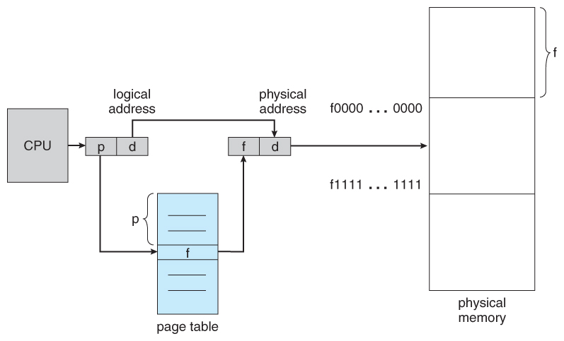  
**Figure 8.10 - Paging hardware**

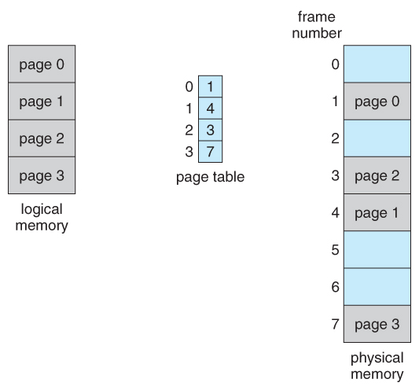  
**Figure 8.11 - Paging model of logical and physical memory**

* Every address generated by the CPU is divided into two parts: a **page number (p)** and a **page offset**
* The page number is used as an index in to a **page table**. The page table contains the base address of each page in physical memory. This base address is combined with the page offset to define the physical memory address that is sent to the memory unit. The paging model of memory is shown in Figure 8.11.
* Page numbers, frame numbers, and frame sizes are determined by the architecture, but are typically powers of two, allowing addresses to be split at a certain number of bits. For example, if the logical address size is 2m and the page size is 2n, then the high-order m-n bits of a logical address designate the page number and the remaining n bits represent the offset.

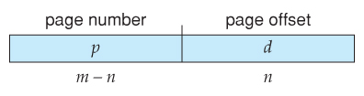

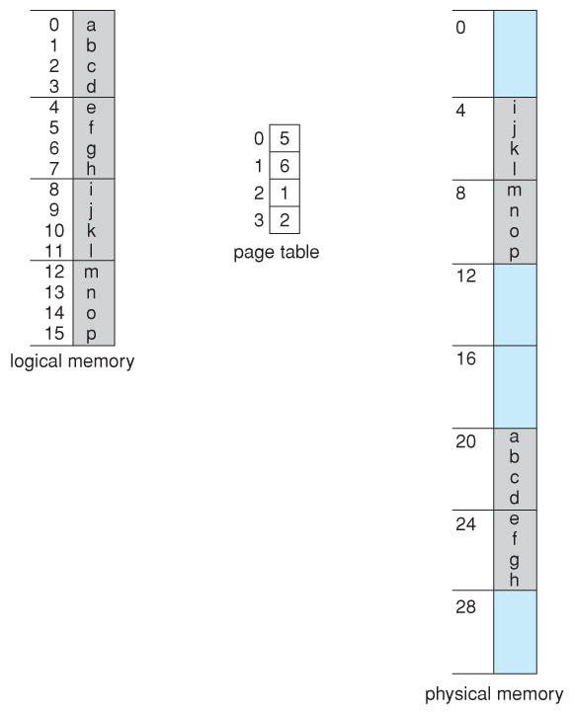  
**Figure 8.12 - Paging example for a 32-byte memory with 4-byte pages**

**Displacement = logical address - (starting address of the page where the address falls)**

Now the memory manager checks in which frame the page is falling and finds the physical address.

**Physical address = displacement + (starting address of frame where the page falls)**

Example:

Consider the memory in Figure 8.9. Here, in the logical address, *n=* 2 and *m* = 4. Using a page size of 4 bytes and a physical memory of 32 bytes (8 pages), we show how the user's view of memory can be mapped into physical memory.

* Logical address 0 is page 0, offset 0. Indexing into the page table, we find that page 0 is in frame5. Thus, logical address 0 maps to physical address 20 [= (5 x 4) + 0].
* Logical address 3 (page 0, offset 3) maps to physical address 23 [ = (5 x 4) + 3].
* Logical address 4 is page 1, offset 0; according to the page table, page 1 is mapped to frame 6. Thus, logical address 4 maps to physical address 24 [ = ( 6 x 4) + 0].
* Logical address 13 maps to physical address 9.

#### 5.2 Hardware Support

* Page lookups must be done for every memory reference, and whenever a process gets swapped in or out of the memory, its page table must be swapped in and out too, along with the instruction registers, etc. It is therefore appropriate to provide hardware support for this operation, in order to make it as fast as possible and to make process switches as fast as possible also.
* One option is to store the page table in main memory, and to use a single register (called the ***page-table base register, PTBR***) to record where in memory the page table is located.
  + Process switching is fast, because only the single register needs to be changed.
  + However memory access just got half as fast, because every memory access now requires ***two*** memory accesses - One to fetch the frame number from memory and then another one to access the desired memory location.
  + The solution to this problem is to use a very special high-speed memory device called the***translation look-aside buffer, TLB.***
    - The benefit of the TLB is that it can search an entire table for a key value in parallel, and if it is found anywhere in the table, then the corresponding lookup value is returned.

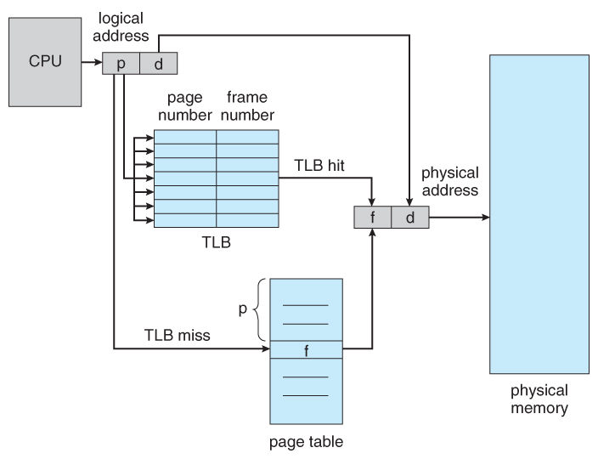  
**Figure 8.14 - Paging hardware with TLB**

* The TLB is very expensive, however, and therefore very small. ( Not large enough to hold the entire page table. ) It is therefore used as a cache device.
* Addresses are first checked against the TLB, and if the info is not there ( a TLB miss ), then the frame is looked up from main memory and the TLB is updated. If the TLB is full, then replacement strategies range from ***least-recently used, LRU*** to random.
* The percentage of time that the desired information is found in the TLB is termed the ***hit ratio***.
  + - **( Eighth Edition Version: )**For example, suppose that it takes 100 nanoseconds to access main memory, and only 20 nanoseconds to search the TLB. So a TLB hit takes 120 nanoseconds total ( 20 to find the frame number and then another 100 to go get the data ), and a TLB miss takes 220 ( 20 to search the TLB, 100 to go get the frame number, and then another 100 to go get the data. ) So with an 80% TLB hit ratio, the average memory access time would be:

0.80 * 120 + 0.20 * 220 = 140 nanoseconds

for a 40% slowdown to get the frame number. A 98% hit rate would yield 122 nanoseconds average access time ( you should verify this ), for a 22% slowdown.

* + - **( Ninth Edition Version: )**The ninth edition ignores the 20 nanoseconds required to search the TLB, yielding

0.80 * 100 + 0.20 * 200 = 120 nanoseconds

for a 20% slowdown to get the frame number. A 99% hit rate would yield 101 nanoseconds average access time ( you should verify this ), for a 1% slowdown.

### Advantages and Disadvantages of Paging

Here is a list of advantages and disadvantages of paging −

* Paging reduces external fragmentation, but still suffers from internal fragmentation.
* Paging is simple to implement and assumed as an efficient memory management technique.
* Due to equal size of the pages and frames, swapping becomes very easy.
* Page table requires extra memory space, so may not be good for a system having small RAM.

**Demand Paging**

Similar to paging, here also the program is divided into pages and the main memory is divided into frames. Instead of loading the entire program into main memory, only essential pages are loaded into main memory, i.eall the pages of the program are present in disk and only page is loaded in main memory only when a request to that page is generated. Transfer of a page from disk into main memory is done by O.S.

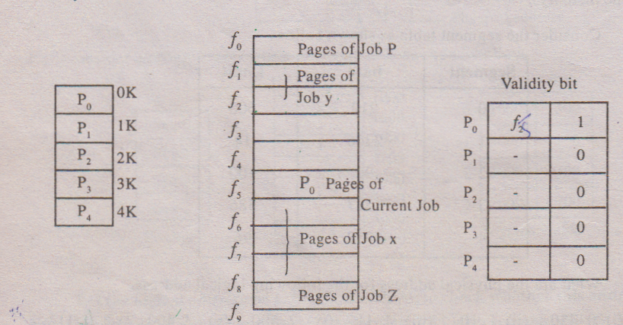

Consider a Job of 5 pages i.e. P0 through P4. Initially all the pages will be ‘present on Disk and there is no page table. When the program is executed, the first page of the Job say P0 will be transferred into main memory and page table is created (as shown above). The page table indicates which page is present in main memory and which pages are not present in main memory. If the validity bit of a page is 0 then it means the page is not present in main memory. If the validity bit of page is 1 then it indicates the page is present in main memory in some frame. The above page table indicates Page P0 is present in main memory in frame 5 and the remaining pages are not present in main memory.

For example CPU generates logical address 500. Then first CPU will find in which page 500 address falls. We know that it falls in page ‘0’. Now CPU will find whether page ‘0’ is present in main memory or not by referring to page table. Page Table indicates that P0 is present in main memory and in frame 5. We know that starting address of frame 5 is 5K.

Displacement = logical address - Starting address of the page where the logical address falls.

= 500-0K

= 500

Physical address = Displacement + Starting address of frame where the page falls

= 500+5K

= 500 + 5 x 1024

= 5620

Suppose CPU generates logical address 1050. We know that, this logical address falls in page 1. The page table tells page 1 is not present in main memory (because the validity bit is zero). Therefore CPU generates page fault i.e. if the required page is not present in main memory then it is known as page fault. Now CPU sends a trap (internal interrupt) to O.S. Now O.S. will transfer from page 1 from Disk into main memory. To transfer, first O.S. will find an empty frame in main memory and the page is transferred to empty frame. Immediately the page table is updated i.e. the validity bit for page 1 is made as 1 and also frame number is also written.

Thus whenever page fault occurs, CPU sends a trap to O.S. and O.S. must perform the following.

1. Save the current status of the Job (i.e. in PCB)
2. Find out to which page the access is being made.
3. Search for the required page on disk.
4. Search for a free frame in main memory.
5. Transfer the page from disk into main memory.
6. Update page table.
7. Restore the status of the Job and continue execution (i.e. retrieve from PCB).

When the above operations are being performed by O.S., CPU will not sit idle it will be executing page of other Jobs.

Sometimes, O.S. finds no free frames in main memory, in such a case O.S. will call an algorithm called page replacement algorithm. This algorithm transfers one of the pages from main memory into Disk. So that space is given for new page. Now O.S. will transfer that page into the empty frame

**SEGMENTATION**

Segmentation is a memory management scheme which supports user view of memory. Here the logical memory is a collection of segments. Each segment is identified by segment. Number and length of segment. The logical address is divided into two

|  |  |
| --- | --- |
| ***Segment No.*** | ***displacement*** |

Though logical address is two dimensional, actual physical memory is one dimensional. Hence they should mapping from two dimensional logical addresses (user defined address) into one dimensional physical address. This is done by using segment table. Each entry of the segment table contains segment base (starting address of segment) and segment limit (length of segment). Whereas CPU generates a logical address, the displacement of logical address must be less than the segment limit. If it is not then a trap sent to CPU indicating it is invalid address and the program execution stops. If displacement is <segment limit then it is valid address. Hence the logical address must be converted into physical address.

Physical address = Displacement + segment base.

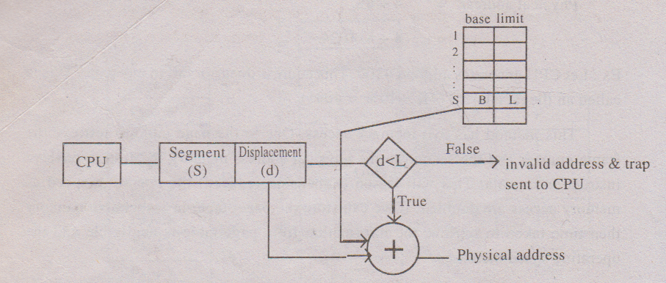

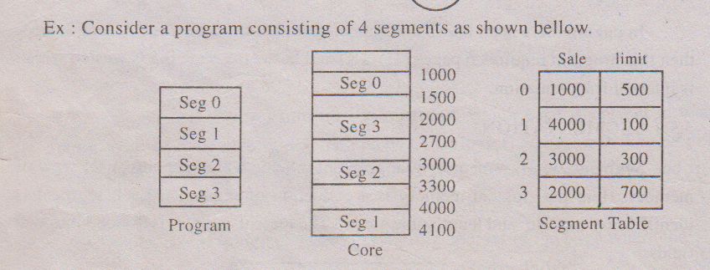

Let the logical address be 1, 53. First we have to check whether this address is valid address or not. Compare the displacement 53 with segment 1 limit 100. Since 53<100 the address is valid.

Physical address = 53 + segment base

= 53+4000

= 4053

Let the logical address be 2,310. First we have to check whether this address is valid or not. Since 310 > seg2 limit 300. So the address is invalid and hence trap is sent.

From the above example we notice that, the segments are of unequal lengths where as in paging all pages are of equal lengths. In segmentation there is no internal fragmentation, because the segment lengths are not predefined, where as in paging there is internal fragmentation because the page lengths are predefined both paging & segmentation suffers from external fragmentation. A segment is made to wait until sufficient memory available. Like paging, in segmentation also the memory accessed two times. One for segment table to retrieve base and limit and second for physical address memory location to retrieve information. Hence operating speed goes down.

**PAGE REPLACEMENT ALGORITHMS**

Whenever page fault occurs and there are no free frames in memory, the operating system has to choose a page to remove from main memory in order to make a space for a new page coming from disk, Though it is simple to remove a random page from main memory, the system performance would be much better if a page is less heavily used is removed from main memory. This is because if a heavily used page is removed from main memory then there is a possibility that the heavily used page may be needed in the future and thereby the number of page faults will increase. There are several page replacement algorithms. The performance of any algorithm is considered, depending on the number of page faults generated, lesser the page faults and more the efficient algorithm is.

**FIFO (First in First out)**

The simplest page replacement algorithm is FIFO replacement algorithm. Here O.S. maintains queue whose elements indicates the page number present in main memory. The top of the queue denotes oldest page (i.e .First in page) and bottom of the queue denotes the page that is recently entered in main memory (i.e. last in page). Whenever, there is a page faults occur and there are no free frames then the first in page is removed i.e. the page at the top of the queue is removed and the new page is inserted at the bottom of the queue.

Consider a page reference string

7 0 1 2 0 3 0 4 2 3 0 3 2 1 2 0 1 7 0 1



Here the most heavily used page is ‘0’ and the least heavily used page is 4. Let us assume there are three frames in main memory, then the algorithm works as follows.

Thus this algorithm produces 15 page faults. This algorithm is easy to understand and easy to implement but efficient point of view, this algorithm is not good. This is because if a heavily used page is at the top of queue then FIFO algorithm replaces this page when there is page fault. Since this page is heavily used there is a probability of that page being referred again in future. Thus FIFO algorithm is inefficient when a heavily used page is at the top of the queue.

**Optimal Replacement Algorithm (ORA):**

The technique in ORA is remove a page which is not referred immediately i.e. replace a page that is not used for a longest period of time. This algorithm guarantees the lowest possible page faults rate for a fixed no. of framed.

**Example:** Consider a page replacement string

7 0 1 2 0 3 0 4 2 3 0.3 2 1 2 0 1 7 0 1



Assume that there are 3 frames in main memory (The page that are going to be referenced during the execution by CPU is known as page replacement string.)

This algorithm produces 9 page faults and considered to be an efficient algorithms compared to the remaining algorithm. If the number of frames increases then number of page faults will decrease and program execution becomes faster this algorithm is difficult to implement. Since it requires future knowledge of the page reference string.

**LRU (Least Recently Used)**

This algorithm keeps track of transactions in main memory. Whenever, a page faults occurs and if there are no free frames. Operating system checks for the page that is not used for the longest time and marks this page for replacement. The idea is that if a page is not used for a long time, then we preassume that the page will not be used in the future and hence mark that page for replacement. In other words, if a page is referred just now, then we preassume that it may be used again in the future and hence do not replace that page. LRU is almost similar to ORA he only difference is that ORA looks forward the page reference string to check which page is not referred in the near future but LRU looks backward the page reference string to check which page is not referred for a long time.

Consider the page reference string

7 0 1 2 0 3 0 4 2 3 0 3 2 1 2 0 1 7 0 1



Here top of queue denotes LRU page (long time back used) bottom of the queue denotes MRU page (page which is just now referred) whenever there is a page fault top of queue will be deleted and new page goes to bottom of queue.

**LOCAL REPLACEMENT VS GLOBAL REPLACEMENT**

|  |  |
| --- | --- |
| A1 | 7 |
| A2 | 5 |
| A3 | 4 |
| B1 | 6 |
| B2 | 5 |
| B3 | 3 |
| B4 | 8 |
| C1 | 6 |
| C2 | 4 |

Let there be three processes A, B, C. present in main memory. Suppose process A gets a page fault then O.S looks at only A pages i.e. A process and the page with lowest age is replaced which is A3. This is called local replacement. Thus in local replacement the number of frames allocated to each process is constant. (i.e. as long as process A is executing there will be three frames forit, as long as process B is executing there will be only 4frames. As long as C is executing there will be only 2 frames. Thus in local replacement, the page to replace from core should belong to same Job as that of page coming in.

On theotherhandif the page, if the lowest age is removed without regard to which Job it belongs then this replacement is called global replacement. Thus in global replacement when process ‘A’ gets a page fault then O.S looks for the page with the lowest age. This is B3. Hence B3 is replaced by A page i.e. A4.

There is a disadvantage in global replacement i.e. as the page of other Jobs are selected for replacement other Jobs start execution. The page fault for them increases. A situation may arise where in always pages of other Jobs are selected for replacement in which case all the pages present in main memory may belong to a single Job which is not desirable. In general if the global replacement is employed then the page fault rate goes beyond control.

**THRASHING**

The set of pages that a process is currently using called as working set. If the entire working set is in main memory then the process will run without causing any page fault if the available memory is too small to hold the entire working set then the process will cause too many page faults and run very slowly. A program causing page fault every few instruction is said to be thrashing i.e. a process is thrashing if it is spending more time for paging (swapping in and out) than executing.

For effective CPU utilization, the degree of multiprogramming (no. of user programs in RAM) should be increased. Thus main memory will contain more number of user programs. So each user program will occupy a small portion of main memory. When a process starts execution it needs more frames (i.e. memory) and hence generates page fault. Let us assume global replacement algorithm is employed, in such a case the process takes frames of other Jobs and when those programs start executing, they also generates page fault and so on. . As they queue up for paging device the ready queue (Job pool) become empty and device queue may become heavy and there by the CPU utilization drops

Now operating system sees the decreasing CPU utilization and increase the degree of multiprogramming by selecting a new process and loads in Ready queue. Since the memory is already occupied with other process page when the new process starts execution it also generates page faults. Thus the CPU utilization has dropped even further. A situation may arise where in the device queue goes on increasing drastically as new Jobs are selected for better CPU utilization and ready queue becomes empty and situation goes out of control. This is called thrashing because of thrashing no working is getting done because process are spending more time in paging than executing.

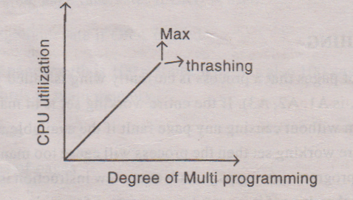**Graphs**

From this graph, we understand that as the multiprogramming increases, CPU utilization also increases once maximum CPU utilization reached, the degree of multiprogramming should not be increased. If we increase thrashing occurs and CPU utilization drops. To avoid thrashing minimum number of Jobs must be selected in the RAM which gives better CPU utilization.

**Disk Structure**

Disks provide the bulk of secondary storage for modern computer systems. Magnetic tape was used as an early secondary-storage medium, but the access time is much slower than for disks. Thus, tapes are currently used mainly for backup, for storage of infrequently used information, as a medium for transferring information from one system to another, and for storing quantities of data that are impractically large for disk systems.

**Disk Scheduling**

One of the responsibilities of the operating system is to use the hardware efficiently. For the disk drives, this means having a fast access time and disk bandwidth. The access time has two major components, Seek time and rotational latency.The disk bandwidth is the total number of bytes transferred, divided by the total time between the first request for service and the completion of the last transfer.



Before understanding this you'll need to be clear with the concept of tracks and sectors. And here's a reference image of a hard disk of the same:



The red circle is a track, you'll have many tracks. A sector is shown in purple. You should also note that the disk will be rotating and there's a head which reads from the rotating disk.

Let us label the tracks from 0 (innermost, inside red circle) to 3 (outermost circular strip). Similarly the purple sector as 0 and going clockwise we name the others till 7. For our convenience we can refer (x,y) as the track sector (aqua blue) whose track is x and sector is y.

**Seek time:** Say you're reading some data from the (0,4). You receive instructions to read from track (2,5). The time it takes for you to move from track 0 to track 2 is seek time.

**Latency:** Once you reach track 2, you realize the head is above the 1st sector you'll have to wait till the disk rotates to the 5th sector so that you can start reading from (2,5). The time you wait for the sector to be accessible by your head here is known as latency.

We can improve both the access time and the bandwidth by scheduling the servicing of disk I/O requests in a good order. Whenever a process needs I/O to or from the disk, it issues a system call to the operating system. The request specifies several pieces of information:

* Whether this operation is input or output
* What the disk address for the transfer is
* What the memory address for the transfer is
* What the number of bytes to be transferred is

If the desired disk drive and controller are available, the request can be serviced immediately. If the drive or controller is busy, any new requests for service will need to be placed on the queue of pending requests for that drive. For a multiprogramming system with many processes, the disk queue may often have several pending requests. Thus, when one request is completed, the operating system has an opportunity to choose which pending request to service next.

**FCFS Scheduling** The simplest form of disk scheduling is, of course, first-come, first-served (FCFS).This algorithm is simple, but it generally does not provide the fastest service. Consider, for example, a disk queue with requests for I/O to blocks on cylinder

98, 183, 37, 122 ,14, 124, 65, 67

In that order. If the disk head is initially at cylinder 53, it will first move from 53 to 98, then to 183, 37, 122, 14, 124, 65, and finally to 67, for a total head movement of 640 cylinders. This schedule is diagrammed in Figure 13.1.



The problem with this schedule is illustrated by the wild swing from 122 to 14 and then back to 124. If the requests for cylinders 37 and 14 could be serviced together, before or after the requests at 122 and 124, the total head movement could be decreased substantially, and performance could be thereby improved

**SSTF Scheduling**

It is reasonable to service all the requests close to the current head position, before moving the head far away to service other requests. This assumption is the basis for the *shortest-seek-time-first (SSTF)* algorithm. The SSTF algorithm selects the request with the minimum seek time from the current head position. Since seek time increases with the number of cylinders traversed by the head, SSTF chooses the pending request closest to the current head position.

For our example request queue, the closest request to the initial head position (53) is at cylinder 65. Once we are at cylinder 65, the next closest request is at cylinder 67. From there, the request at cylinder 37 is closer than 98, so 37 is served next. Continuing, we service the request at cylinder 14, then 98, 122, 124, and finally at 183 (Figure 13.2). This scheduling method results in a total head movement of only 236 cylinders—little more than one-third of the distance needed for FCFS scheduling. This algorithm gives a substantial improvement in performance.



SSTF scheduling is essentially a form of shortest-job-first (SJF) scheduling, and, like SJF scheduling, it may cause *starvation* of some requests. Sometimes requests may arrive at any time. Suppose that we have two requests in the queue, for cylinders 14 and 186, and while servicing the request from 14, a new request near 14 arrives. This new request will be serviced next, making the request at 186 wait. While this request is being serviced, another request close to 14 could arrive. Then a continual stream of requests near one another could arrive, causing the request for cylinder 186 to wait indefinitely. This scenario becomes increasingly likely if the pending-request queue grows long.

Although the SSTF algorithm is a substantial improvement over the FCFS algorithm, it is not optimal. In the example, we can do better by moving the head from 53 to 37, even though the latter is not closest, and then to 14, before turning around to service 65,67,98,122,124, and 183. This strategy reduces the total head movement to 208 cylinders

**SCAN Scheduling** In the SCAN algorithm, the disk arm starts at one end of the disk, and moves toward the other end, servicing requests as it reaches each cylinder, until it gets to the other end of the disk. At the other end, the direction of head movement is reversed, and servicing continues. The head continuously scans back and forth across the disk. We again use our example.

Before applying SCAN to schedule the requests on cylinders 98, 183, 37,122,14, 124, 65, and 67, we need to know the direction of head movement, in addition to the head's current position (53). If the disk arm is moving toward 0, the head will service 37 and then 14. At cylinder 0, the arm will reverse *and* will move toward the other end of the disk, servicing the requests at 65, 67, 98,122,124, and 183 (Figure 13.3). If a request arrives in the queue just in front of the head, it will be serviced almost immediately; a request arriving just behind the head will have to wait until the arm moves to the end of the disk, reverses direction, and comes back.



The SCAN algorithm is sometimes called the *elevator algorithm,* since the disk arm behaves just like an elevator in a building, first servicing all the requests going up, and then reversing to service requests the other way.

**C-SCAN Scheduling**

*Circular SCAN (C-SCAN)* is a variant of SCAN that is designed to provide a more uniform wait time. Like SCAN, C-SCAN moves the head from one end of the disk to the other, servicing requests along the way. When the head reaches the other end, however, it immediately returns to the beginning of the disk, without servicing any requests on the return trip (Figure 13.4). The C-SCAN scheduling algorithm essentially treats the cylinders as a circular list that wraps around from the final cylinder to the first one.



**LOOK Scheduling** The arm goes only as far as the final request in each direction. Then, it reverses direction immediately, without first going all the way to the end of the disk. These versions of SCAN and C- SCAN are called LOOK and C-LOOK.



**Disk Management:**

1. **Disk formatting**

The most basic form of disk organization is called formatting. Formatting prepares the hard disk so that files can be written to the platters and then quickly retrieved when needed. Hard disks must be formatted in two ways: physically and logically.  
  
1. [Physical Disk Formatting](http://www.partition-magic-manager.com/partition-magic/partition-magic-help/WhatIsDiskFormatting.php#a)  
2. [Logical Disk Formatting](http://www.partition-magic-manager.com/partition-magic/partition-magic-help/WhatIsDiskFormatting.php#b)  
  
**PhysicalDisk Formatting**  
A hard disk must be physically formatted before it can be logically formatted. A hard disk's physical formatting (also called low-level formatting) is usually performed by the manufacturer.

Physical formatting (pictured below) divides the hard disk's platters into their basic physical elements: tracks, sectors, and cylinders. These elements define the way in which data is physically recorded on and read from the disk.   
  
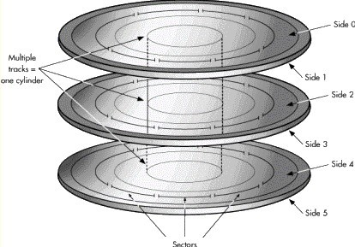  
  
1.**Tracks**are concentric circular paths written on each side of a platter, like those on a record or compact disc. The tracks are identified by number, starting with track zero at the outer edge.  
2. Tracks are divided into smaller areas or **sectors**, which are used to store a fixed amount of data. Sectors are usually formatted to contain 512 bytes of data (there are 8 bits in a byte).  
3. A **cylinder**is comprised of a set of tracks that lie at the same distance from the spindle on all sides of all the platters. For example, track three on every side of every platter is located at the same distance from the spindle. If you imagine these tracks vertically connected, the set forms the shape of a cylinder.  
  
  
After a hard disk is physically formatted, the magnetic properties of the platter coating may gradually deteriorate. Consequently, it becomes more and more difficult for the read/write heads to read data from or write data to the affected platter sectors. The sectors that can no longer be used to hold data are called bad sectors.

Fortunately, the quality of modern disks is such that **bad sectors**are rare. Furthermore, most modern computers can determine when a sector is bad; if this happens, the computer simply marks the sector as bad (so it will never be used) and then uses an alternate sector.  
  
**Logical Disk Formatting**  
After a hard disk has been physically formatted, it must also be logically formatted. Logical formatting places a file system on the disk, allowing an operating system (such as DOS, Windows, or Linux) to use the available disk space to store and retrieve files. Different operating systems (OS) use different file systems, so the type of logical formatting you apply depends on the OS you plan to install.

Before a disk is logically formatted, it can be divided into partitions. Each partition can then be formatted with a different file system, allowing you to install multiple operating systems. Dividing your hard disk into partitions also allows you to use disk space more efficiently.

**BOOT BLOCK**

The boot block is usually the first block in the hard disk.**Booting**is a step by stepprocess by which the operating system’s files and processes are located in the harddisk, and then sequentially copied from the hard disk to the lower memory block ofthe RAM, and finally to the CPU registers.

Generally the booting of the operatingsystem is governed by a small program called the **bootstrap loader**. The bootstraploader determines the order of loading the files and activating the initial processes ofthe operating system. The bootstrap loader is stored usually in the first block in the hard disk.

If multipleoperating systems are installed in different partitions, each partition may contain oneseparate boot block, one each for a different operating system. If a disk contains aboot block it is called a boot disk, if a partition contains a boot block it is called a bootpartition. The motherboard of every computer system has a BIOS chip (BIOS stands for BasicInput Output System and in responsible for the basic hardware level settings of the computer). Whenever the computer is turned on, a program in the BIOS chip detectsthe bootable partitions and selects the appropriate bootstrap loader to boot the correctoperating system into memory

**BAD BLOCK**

Assuming the hard disk has several data blocks, there is always thepossibility that the blocks can malfunction. The defective blocks are called badblocks. There could be two different types of defects: soft and hard.

In**soft defect**or**soft error**, the block is not damaged physically, only the data stored in that block islost. In**hard defect**or**hard error**, the damage isphysical; meaning the hardware ofthe block is damaged. The soft defects are recovered easily by running some specialoperating system routines. The hard defects cannot be recovered. The only solution tomanage the hard defects is to keep some spare data blocks in the hard disk. Forexample, in a 40 GB hard disk, 20 MB of additional disk space might be used asspare, which is not shown to the user. If the operating system finds out that there is ahard defect in a bad block, the bad block is replaced from a good block taken out ofthe 20 MB spare space

**Swap-Space Management**

**Swap-space use**:

The operating system needs to release sufficient main memory to bring in a process that is ready to execute. Operating system uses this swap space in various ways. Paging systems may simply store pages that have been pushed out of main memory. UNIX operating system allows the use of multiple swap spaces. These swap space are usually put on separate disks, so the load placed on the I/O system by paging and swapping can be spread over the systems I/O devices.

**Swap-space location:** Swap space can reside in two places: 1. Separate disk partition 2. Normal file system If the swap-space is simply a large file within the file system, normal file system routines can be used to create it, name it and allocate its space. This is easy to implement but also inefficient. External fragmentation can greatly increase swapping times. Catching is used to improve the system performance. Block of information is cached in the physical memory, and by using special tools to allocate physically contiguous blocks for the swap file.

Swap-space can be created in a separate disk partition. No file system or directory structure is placed on this space. A separate swap space storage manager is used to allocate and deallocate the blocks. Thismanager uses algorithms optimized for speed. Internal fragmentation may increase. Some operating systems are flexible and can swap both in raw partitions and in file system space. Solaris 2 is an example.

**RAID**

RAID stands for redundant array of independent disks. The name indicates that the disk drives are independent, and are multiple in numbers. How the data is distributed between these drives depends on the RAID level used.

RAID is fault tolerant because in most of the RAID level's data is redundant in multiple disks, so even if one disk fails, or even two sometimes, the data will be safe and the operating system will not be even aware of the failure. DATA loss is prevented due to the fact that data can be recovered from the disk that is not failed.

**Stripping in RAID:**

Writing data on a single disk is slower, but writing data by spreading it on multiple disks is faster (because data is written in small chunks to different disks, and also fetched in small chunks by different disks) When data is fetched from different disks, the CPU does not have to wait, because the throughput will be a combined one of all the disks. Each and every disk drive are partitioned in small chunks (ranges from 4kb to 512kb sometimes).

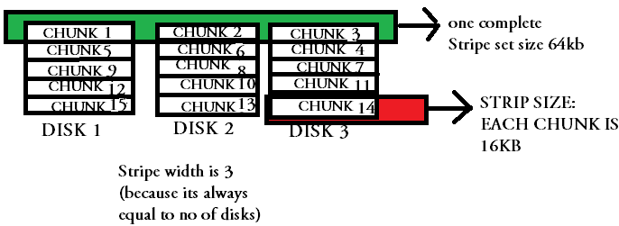

In the above shown example diagram you can see that all three disks contains different data (data that needs to be stored, will be striped in chunks and will be spreaded across different disks).

There is no redundancy in this method, but is better known for high performance.

**Mirroring in Raid**

Mirroring is a mechanism in which the same data is written to another disk drive. The main advantage of mirroring(multiple sets of same data on two disks), is that it provides 100 percent redundancy.

Suppose there are two drives in mirroring mode, then both of them will contain an exact same copy of data. So even if one disk fails, the data is safe on the other.

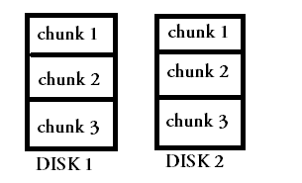

**Hot spares in Raid**

Hot Spare is an extra drive added to the disk array, to increase the fault tolerance. If you have a hot spare in your Raid disk array, the Raid controller will automatically start rebuilding data on to that hot spare drive, if one of the disk from the array fails.

Which means the hot spare will automatically take the role of the failed drive once data rebuilding is complete.

You can later on replace your failed drive.

RAID management software's will provide you with a mechanism to specify the hot spare drive for your array.

**Different Levels of Raid**

**RAID 0 or No RAID**

If your main priority is performance, then raid 0 fits right.

An important fact that should be kept in mind is that, RAID 0 does not provide any kind of redundancy. Which means even if one drive fails, your data is at risk.

It is simply striping done on your disk array. Data is broken into smaller chunks and are spread across the number of disks you have.

It has no mirroring, no parity(which means no redundancy !)RAID(redundant array of independent disks), can be classified to different levels based on its operation and level of redundancy provided.

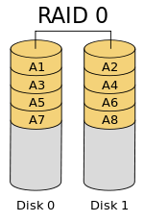

In fact raid level 0 is not RAID, because raid was primarily build for redundancy, and raid 0 does not provide any kind of redundancy, although it provides high performance.

**Raid level 1(RAID 1)**

RAID 1 implements heavy use of mirroring. All data in the drive is duplicated to another drive. It can be used in a situation where fault tolerance is of primary importance.

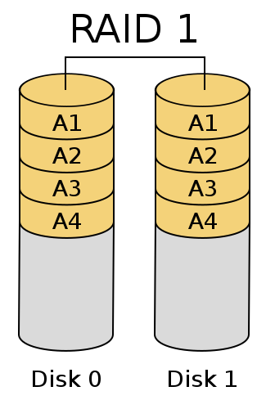

**RAID-3:**

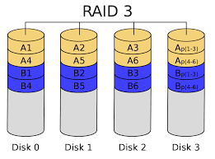

RAID 3 is a [RAID](https://www.techtarget.com/searchstorage/definition/RAID) configuration that uses a [parity](https://www.techtarget.com/searchstorage/definition/parity) disk to store the information generated by a [RAID controller](https://www.techtarget.com/searchstorage/definition/RAID-controller) instead of [striping](https://www.techtarget.com/searchstorage/definition/RAID-0-disk-striping) it with the data.

Because the parity information is on a separate [disk](https://www.techtarget.com/searchstorage/definition/hard-disk-drive), RAID 3 does not perform well when tasked with numerous small [data](https://www.techtarget.com/searchdatamanagement/definition/data) requests. RAID 3 is a better choice for [applications](https://www.techtarget.com/searchsoftwarequality/definition/application) that have long sequential data transfers, such as [streaming media](https://www.techtarget.com/searchunifiedcommunications/definition/streaming-video), graphics and video editing.

**Raid Level 5(RAID 5)**

RAID level 5 uses striping, so data is spread across number of disks used in the array, and also provides redundancy with the help of parity.

RAID 5 is a best cost effective solution for both performance and redundancy. Striped method of storing data always improves performance, and parity used in this level of raid is distributed parity.

Minimum number of disks required for raid 5 is 3, and maximum can go upto 32(depending on the RAID controller used.)

One important fact to note is that, reading rate in raid 5 is much better than writing. This is because reading can be done, by a combined rate of all disks used.

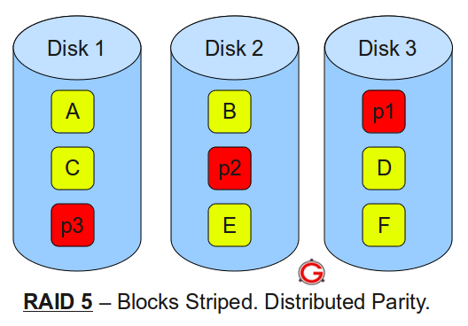

**Raid level 6 (RAID 6)**

Raid level 6 is very much similar to raid level 5, but it has got one more added advantage.

The added advantage is that it can sustain 2 drive failures instead of 1. This is achieved again with the help of parity. In raid level 6, double distributed parity is used to achieve this level of redundancy.

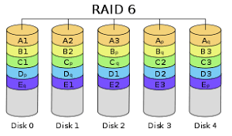

You can cleary see in the above diagram, each and every stripe set contains two parity on multiple disks.

So even if two disks get failed at one time, data can still be recreated.

Performance of raid 6 is very much similar to performance of raid 5, its much well suited for reads that writes

**Raid 10 (Combination of Raid 0 and Raid 1)**

Raid 10 is a good solution that will give you both the performance advantage of raid 0 and also the redundancy of raid 1 mirroring.

Raid 10 was made by a combination of raid 0 and raid 1. And hence you get qualities of both the raid levels..

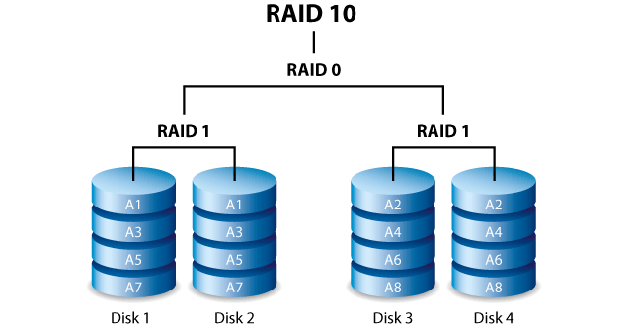

If you see the above diagram data is redundant with a duplicate set in raid 1, and also is stripped across multiple raid 1 groups to achieve performance.

This is best suitable for heavy IO usage & also provides 100 percent redundancy. Minimum number of drives required is 4. It is quite expensive, as you can clearly see that you are dedicating one disk per raid 1 array for redundancy.

But is an excellent choice for both performance and redundancy.

**Raid-2**

* This uses bit level striping. i.e Instead of striping the blocks across the disks, it stripes the bits across the disks.

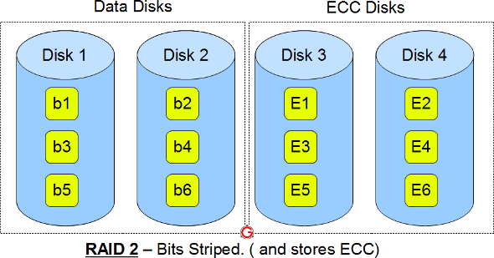

* In the above diagram b1, b2, b3 are bits. E1, E2, E3 are error correction codes.
* You need two groups of disks. One group of disks are used to write the data, another group is used to write the error correction codes.
* This uses Hamming error correction code (ECC), and stores this information in the redundancy disks.
* This is not used anymore. This is expensive and implementing it in a RAID controller is complex, and ECC is redundant now-a-days, as the hard disk themselves can do this

**Summary of different RAID levels**

RAID 0 uses striping for high performance. Raid 0 cannot be considered as RAID as it does not provide fault tolerance.

RAID 1 uses mirroring for redundancy.

RAID 5 uses striping as well as parity for redundancy. It is well suited for heavy read and low write operations.

RAID 6 uses striping and double parity for redundancy.

RAID 10 is a combination of raid 1 and raid 0. It also provides heavy redundancy because of mirroring, and also provides performance as the data is striped across multiple raid 1 groups.